CSCI-6461: PROJECT – PART 2

Designed by – TEAM 5
Avish Kaushik
Harichandana Samudrala

Technology Used
Java OpenJDK 23

How To Run?
- Make sure you have updated version of JAVA installed
- Download the ZIP and extract Project1.txt file and JAR file in the same place.
- Please use the following command in Terminal/CMD to run the JAR:

java -jar Simulator.jar

- After it run, you can provide the input file by clicking on IPL button which will open a dialog box. Select Project1.txt file from that dialog box and click open.
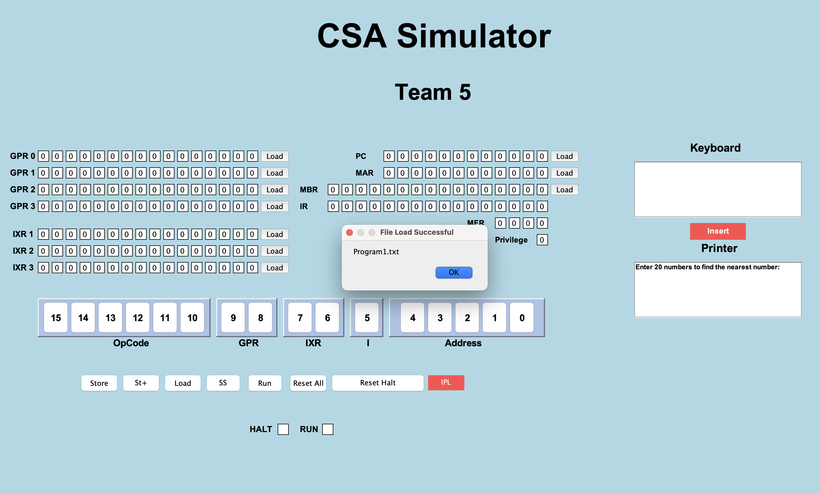

It will show that File Load Successful.

- You can start entering 20 values in the Keyboard section and can click on Insert to add them.
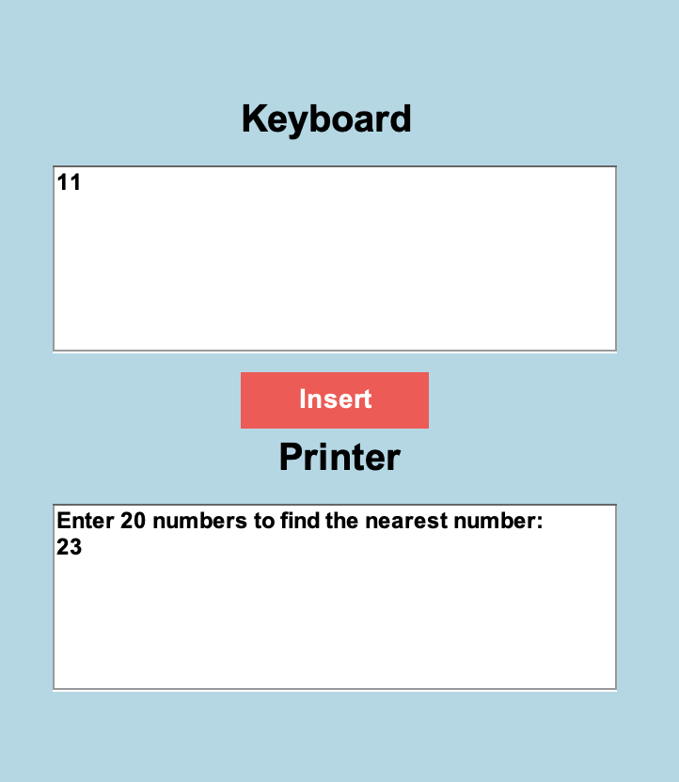
- After providing 20 numbers, it will give you option to enter a number you to find the closest number within the given 20 elements.
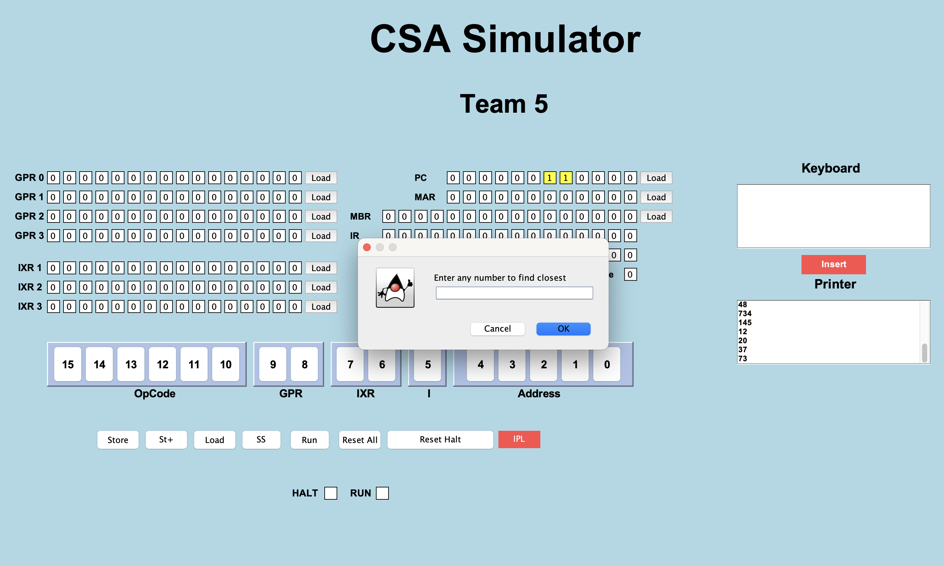
- After entering the number in Pop-up panel, it will find and display you the closest number to it among the given 20 elements.
Example: I entered 66 and closest to it was 65 which has been provided in Printer screen
